Timecard Approval

- You will click on “Timecard Approval” on the left hand side under the “Employee Info” tab.
- This will bring up the screen shown below if the pay period has already ended. If the period is not over you can go to page #3 for the view that will come up. You will need to change the Current (by the blue arrow) to “Select Year” and then click on the pay period you wish to approve.
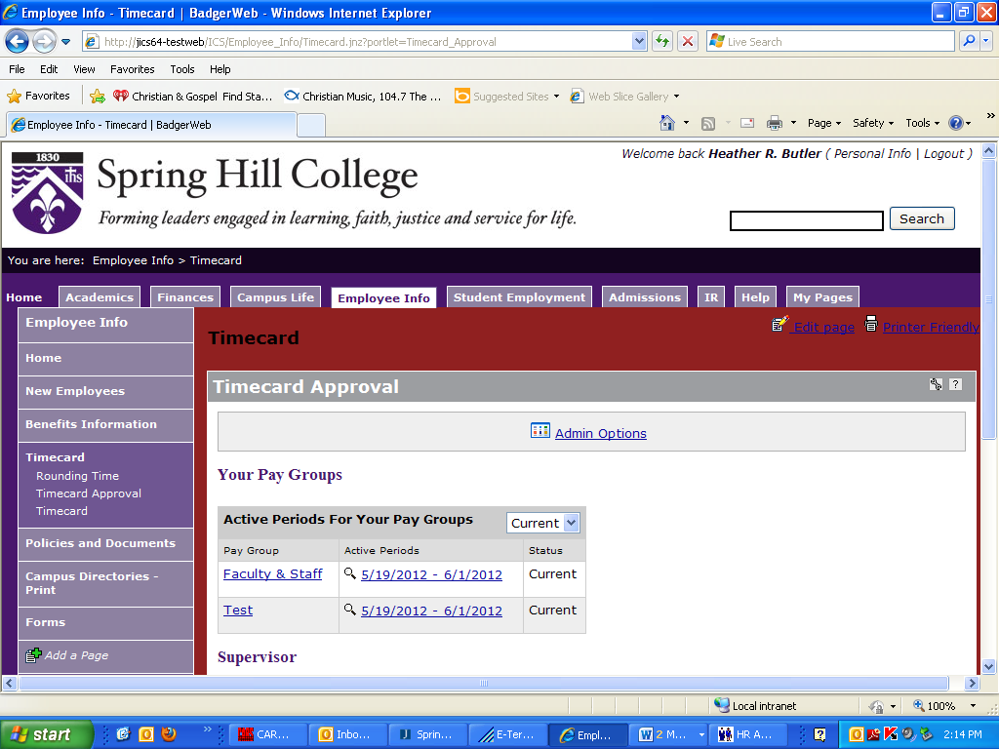
- You will now want to click on the pay group faculty & staff or the dates of the pay period. As a general rule you should not see any other pay groups other than faculty & staff. The next screen should appear as show below.

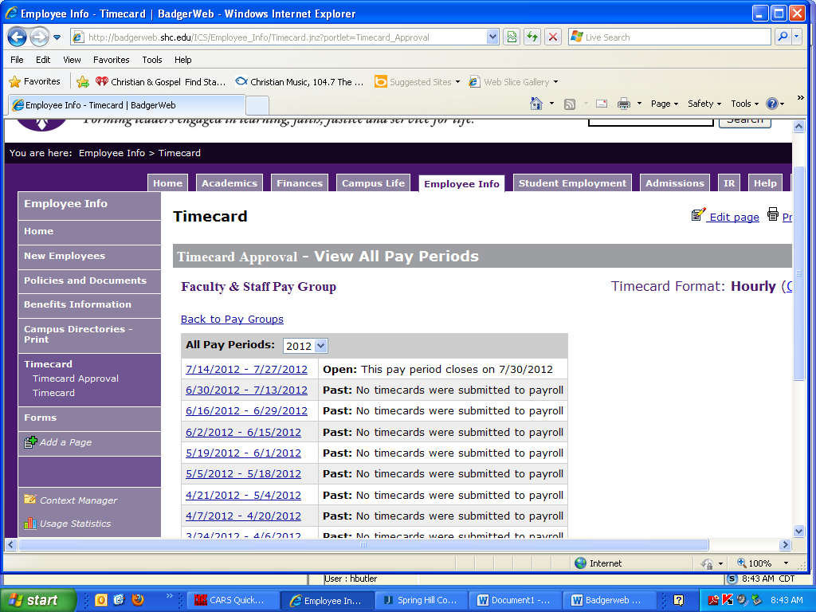
- Here you can click on the open pay period dates to approve that pay period.

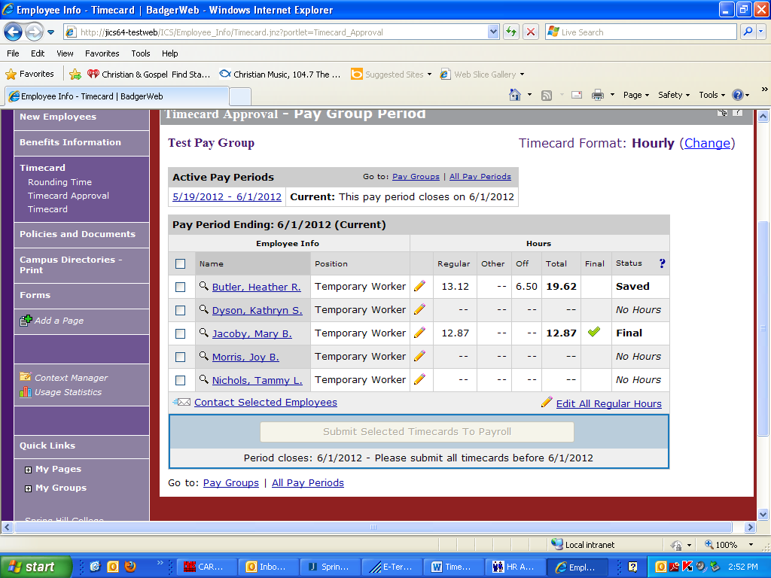

- Here you can edit the hours that the employee has entered if needed. Simply click on the pencil or their name. This will allow you to adjust their total hours and enter a comment if you would like to. After you click on the box to enter hours there is not a cursor blinking in the box, but when you begin typing the hours should appear.
- If you update the employee’s timecard you may then submit it to payroll without the employee doing anything further. The employee will then get an email stating changes have been made to their timecard and they can login to view the changes.
- You can also reopen the employee’s timecard by clicking on their name if they have finalized it. If you reopen their timecard they can then edit or add to their time. This can be done as long as you have not submitted the time to payroll.
- If you wish to email the employee with a question you may mark the box beside their name and click “Contact Selected Employees” below the list of employees.
- The blue question mark next to “Status” gives a list and explanation of the “statuses” you may see.
- To submit their time you mark the box beside their name and then click “Submit selected timecards to payroll”.
- Please make sure all employees have entered time each pay period and that you submit all of them to payroll.

Alternate Approver

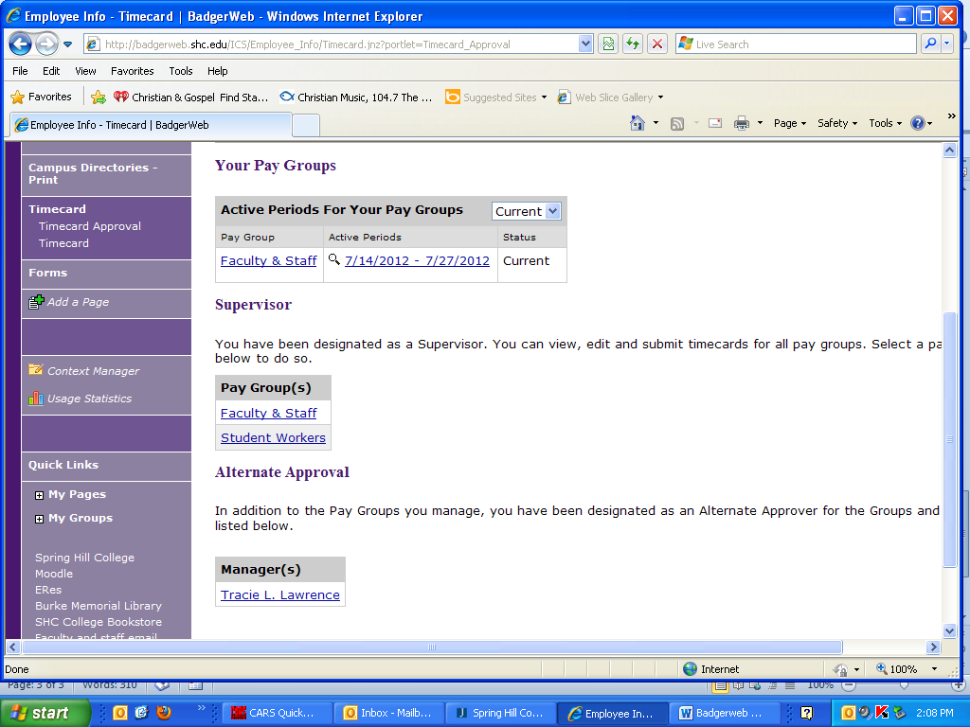

- Click employee info
- Click timecard approval on the left
- The screen above should appear. If you normally do not approve timesheets you will not see the “Your Pay Groups” section.
- Under the “Alternate Approval” section you would click the name of the person you will approve timesheets on behalf of. Once you click on their name you can began approving by using the instructions from the beginning of this document.

